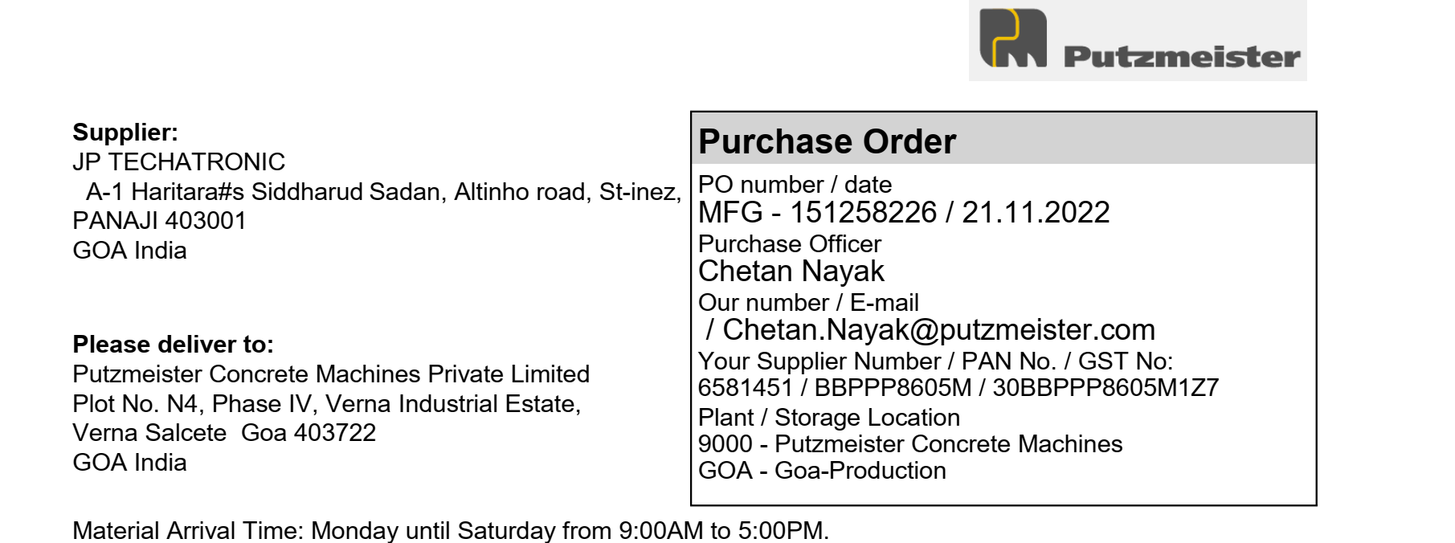

|  |  |  |  |  |  |  |
| --- | --- | --- | --- | --- | --- | --- |
| **Sr. No** | **Material** | **Description** | **Quantity** | **Unit** | **Price Per Unit** | **Net Price (INR)** |
| 1 | 719381 | Monochrome laserjet printer CanonLBP6030BJ | 10 | PCS | 8299 | 82990 |
|  |  |  |  | CGST | 9% | 7469.1 |
|  |  |  |  | SGST | 9% | 7469.1 |
| Delivery Schedule |  |  |  |  |  |  |
| Date | 12.12.2022 |  |  |  |  |  |
|  |  |  |  | Basic Total | | 82990 |
|  |  |  |  | Central GST | | 7469.1 |
|  |  |  |  | State GST | | 7469.1 |
|  |  |  |  | **Total In INR** | | **97928.2** |

Amount In Words:

Ninety Seven Thousand Nine Hundred Twenty Eight Rupees Twenty Paise

Send Original/Duplicate/Invoice along with material.

If non excisable material – TAX invoice – 2 copy in original.

If material is received without the required documents and details, it will not be received in the plant.

It is necessary to put the Putzmeister order number on every invoice.

Terms and conditions applied.



